Sample Paper – 2008
Class – X
Subject - Biology

Set – 1
[Full Marks 80 ] [Time – One hour and a half]
Section – I (40 marks)
Attempt all questions from this section
Q.1(a) Name the following :-
(i) The shortest phase of mitosis. (ii) The unit of the nervous system.
(iii) Shrinkage of protoplasm when a cell is kept in salt solution.
(iv) The site of production of sperm in man. (v) Protein deficiency disease.
(b) Choose the most appropriate answer :
(i) DPT stands for :
[p] Diphtheria, Polio and Tetanus [q] Diphtheria, Pertussis and Tetanus
[r] Dysentery, Polio and Typhoid [s] Diphtheria, Polio and Typhoid.
(ii) Population explosion has led to :
[p] Environmental pollution [q] Deforestation
[r] Shortage of natural resources [s] Better medical facilities to people.
(iii) Secretion of indocrine glands are called :
[p] Hormones [q] Enzymes [r] Nucleic acids [s] Amino acids.
(iv) Which of the following does not affect the rate of transpiration ?
[p] Light [q] Humidity [r] Wind [s] Age of the plant.
(v) Removal of anthers from flowers artificially is known as :
[p] Castration [q] Emasculation [r] Cutting [s] Cross-pollination.
(c) Complete the following statements by choosing the correct alternative out of those given in brackets.
(i) The spindle fibres are made of ___________ [Microtubule / Matrix / Cenriole].
(ii) Starch can be tested by _________ [Iodine / Hydrochloric acid / Alcohol].
(iii) Calcium carbonate particles present in endolymph are called ________ [Otolith / ampuiiae / Cochlea].
(iv) Testis is covered by _________ [Theca externa / Theca interna / Tunica albuginea].
(v) Serum gives ____________ [Active immunity / Passive immunity / No immunity].
(d) Mention if the following statements are true (T) or false (F).
(i) Hypertrichosis is X-linked. [ ].
(ii) Root hair are thin, delicate prolongations of cortex. [ ].
(iii) Hormones are produced by exocrine glands. [ ].
(iv) The cutting of fallopian tube in female is called vasectomy. [ ].
(v) The Red Cross symbol can be seen on ambulances. [ ].
(e) Define the following terms :-
(i) Mitosis, (ii) Guttation, (iii) Hypermetropia, (iv) Fertilization and (v) Immunity.
(f) Differentiate between the following terms :-
(i) Test cross and Back cross, (ii) Diffusion and Osmosis, (iii) Natality and Mortality
(iv) Antiseptic and Disinfectant, (v) Congenital disorder and Acquired diseases.
(g) Give reason for the following :-
(i) Leaves are reduced to spine in cactus.
(ii) Grass is killed if salt is sprinkled on it.
(iii) It is necessary to place a plant in dark before starting an experiment on photosynthesis.
(iv) The deficiency of Vitamin A causes night blindness.
(v) Patients suffering from diabetes are treated with insulin.
(h) Match the following :-
(i) Zygotene | (a) scientific study of population
(ii) Testes | (b) Penicilline
(iii) Demography | (c) Geneva
(iv) Antibiotic | (d) Sperm
(v) WHO | (e) Synapsis

Section – II (40 Marks)
Answer ANY FOUR questions from this section.
2(a) What is interphase ? Mention three significant changes that occur in a cell during interphase. [5]
(b) Define mutation. Suggest two ways by which it can happen to human cells. [5]
3(a) The following diagram represents a plant cell after being placed in a strong sugar solution. Write down what type of changes occur in the parts labelled 1 to 5. [5]
fig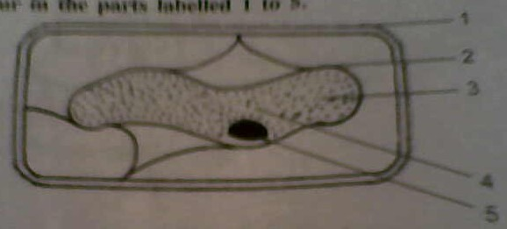
(b) Figure given below represents the vertical section of a leaf.
(i) Name the structure shown in the leaf section.
(ii) Name the parts labelled 1 to 5.
(iii) How many leaf veins have been shown in this section ? [5]
fig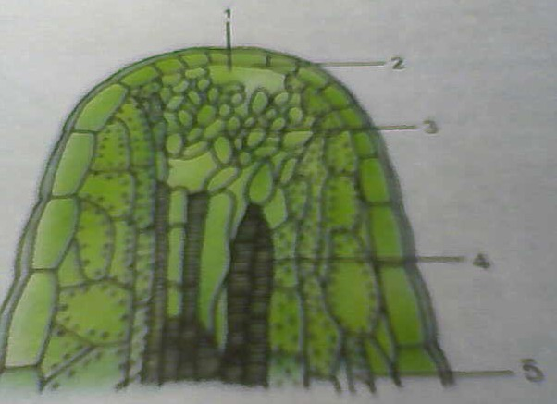
4(a) Write short notes on : (i) Light reaction (ii) Dark reaction. [5]
(b) In the given figure, label the parts 1 to 14. [5]
fig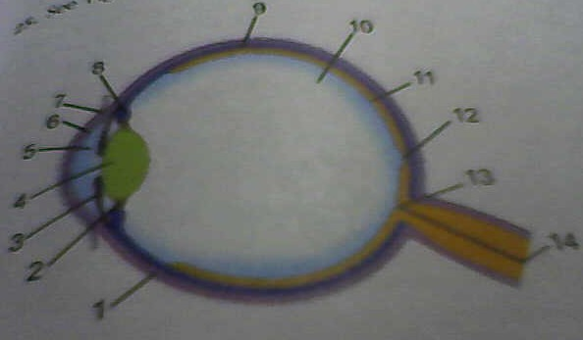
5(a) Why old people are unable to perceive taste easily ? Mention the location of the following tastes of the tongue : sweet, salt, bitter and sour. [5]
(b) What is Red Cross ? List three functions of the Red Cross. [5]
6(a) Find the odd one out :
(i) thyroid, pituitary, liver, adrenal
(ii) glucagons, adrenalin, urea, insulin
(iii) growth hormone, TSH, ACTH, progesterone
(iv) cretinism, goiter, myxoedema, gigantism
(v) aldosterone, insulin, adrenaline, noradrenaline [5]
(b) Mention the functions of :
(i) Seminal vesicles, (ii) Uterus, (iii) Testicles,
(iv) Fallopian tube, (v) Corpus Luteum. [5]
7(a) (i) What is the age limit for marriage by law for boys and girls in India ?
(ii) Name the two surgical techniques (one each for human male and female) which can be used to prevent pregnancy.
(iii) What is the emblem (sign) of family planning and family welfare in India ? [5]
(b) Write briefly about the following :
(i) Principle of vaccination in producing immunity against a disease.
(ii) Immunization schedule for the newly-born child. [5]
Best of luck
M. P. Keshari [09434150289]

